Chuanjie ZANG

699382953

<https://www.behance.net/gallery/99034409/Unexeq-Planetariq?tracking_source=search_projects&l=40>

The creative expression that merges inner feelings with artistic skills is indeed art, and from this perspective, the core of art lies in expression. In my childhood, I learned from books that Earth had sent a golden record into the universe, containing an introduction to Earth's civilization. The visual patterns depicting the solar system and humanity on the golden record in the books left a profound impression on me. Drawing inspiration from the close association between the golden record and the cosmos, I decided to use a minimalist artistic style similar to that of the golden record in the design of the book cover, spine, and back cover for this novel 'The Three-Body Problem,' which narrates the story of the universe and the survival of humanity.

To arrive at this design, I decided to emulate the design style of Russian artist Ivan L in Unexeq - Planetariq, i.e. there is a minimalist design about the universe. In the specific design I will imitate his use of colours, lines and typography in order to present the book design of the novel 'The Three-Body Problem' in my mind.

Ivan L, Unexeq - Planetariq

<https://www.behance.net/gallery/99034409/Unexeq-Planetariq?tracking_source=search_projects&l=40>

Preliminary Draft

1. I set the novel's front and back covers at 6x9inch and the spine at 1.5x9inch

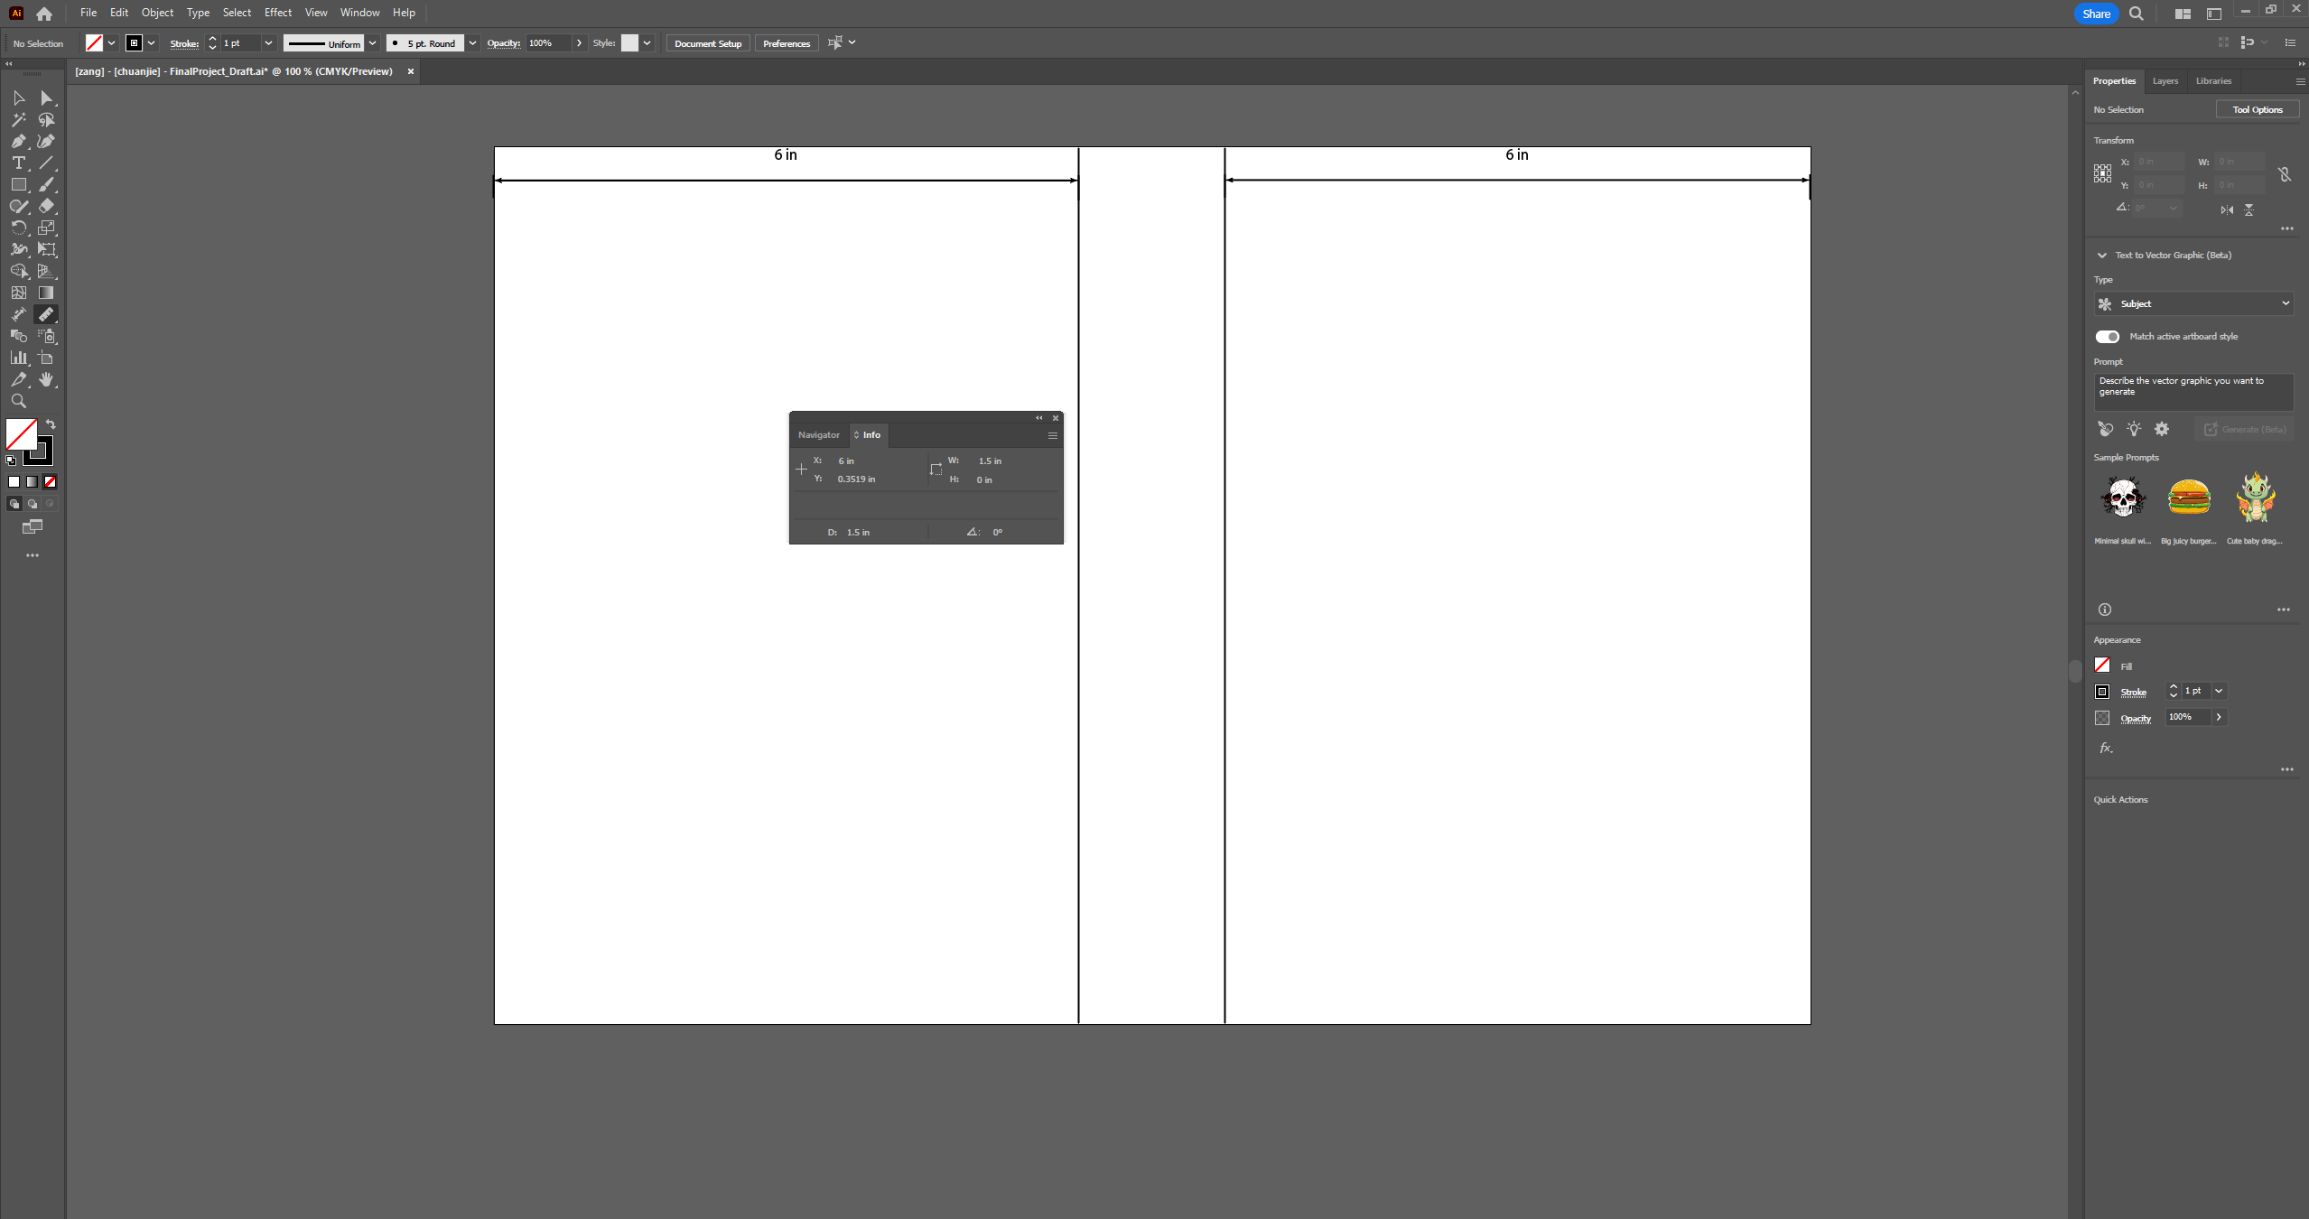

1. Cover: Using a 3D effect with a perspective of diminishing size, a simplified illustration of the Three-Body System surrounds the book title "Three-Body," depicting the primary focus of the story on the Trisolaran civilization and emphasizing the themes of science fiction and the universe.
2. Spine: Vertical lines and the title 'The three body problem' are used, and a place is left for the author's name.
3. Back Cover: The radar station serves as the tool for the initial contact between humans and the Trisolarans in the story. The orientation of the radar corresponds to the Three-Body System on the cover, employing the same near-to-far perspective. Below the radar, a minimalist depiction of the Three-Body System separates space, providing ample room for publisher information, endorsements, and other details.
4. 